



**Graduation Project Report**

**Supervised by : Dr.Mohamed Hamed**

**IT Department**

**Project title : Augmented Reality in lifestyle**

**Name ID**

**Mohamed Essam El-Deen Fathy 20130209**

**Mohamed Saeed El-Sayed 20130198**

**Menna-Allah Magdy Mohamed 20130249**

Contents

1. Introduction 3

2. Problem Statement: 4

3. Objective: 5

4. Related Work: 6

4.1 Lego 6

4.2 Converse 7

5. Initial Architecture and Design: 8

5.1 Unity 8

5.2 Vuforia: 9

5.3 Firebase: 10

5.4 Android (operating system): 14

6. Plan: 16

7. Current State: 16

8. Future work: 18

9. Conclusion: 19

10. References 20

1. Introduction**:**

Augmented reality (AR) technology makes it possible for the digital realm and the real world to combine in a seamless environment. With AR, digital components and overlays work to enhance and elevate real life scenarios in countless ways. Not only is augmented reality consumed by only tech corporations and gaming communities, but it is also becoming a more mainstream technology embraced by large retailers and customers alike. Many major consumer-driven companies are now successfully using augmented reality technology and AR apps to enrich their customers’ experiences and interactions with their brand, to ultimately boost sales.

We can also use AR to boost retail presence and sales through enriching their customer interaction and buying experience

Augmented reality technology is becoming much more of mainstream among retail businesses. Consumers are increasingly tech savvy who tend to make their purchasing decision from home or on a mobile device. Augmented reality is the Segway for retailers to create more meaningful, memorable shopping experiences for customers while leveraging your digital audience in the process.

Augmented reality technology and AR apps have limitless marketing potential for retailers. In order to stay competitive and relevant in your industry, consider embracing and integrating AR into your business.

We know that our customers are increasingly using their smartphones as a shopping companion and we want to continue to find ways to inspire them and facilitate a better shopping experience

Augmented reality, or AR, is an amazing, cutting-edge technology that offers an engaging experience that leverages the camera lens, the GPS system, and the Wi-Fi in your smart phone, tablet, or laptop.

It combines the view through your camera lens with computer-generated data and imagery to augment, or enhance, what we perceive we're looking at. Augmented reality when combined with print, can send a powerful marketing message.

There are two categories of augmented reality :

* **Location-Based AR:**

A location-Based AR product uses your smart phone or tablets geolocation and directional sensors to overlay additional information with regard to where the user is. A location-based AR program would know exactly where they at direction they're facing.

* **A marker or vision-based AR**

A marker or vision-based AR product recognizes visual objects or codes without regard for location. Vision-based AR works very well in combination with printed media Marketers can use the technology to bring their printed visuals

Lots of great surprises happen when you move your mobile device over the printed page.

Augmented reality, like QR code technology, requires the installation of a software application to activate the technology. However, unlike QR codes, where the QR reader app recognizes most QR codes, augmented reality is less generic in that sense. Each AR product usually requires the installation of a specific app. In most cases, Augmented Reality requires custom software development "unity"

# Problem Statement:

Buying new furniture can be time-consuming and overwhelming as it’s the considered the hardest part about buying furniture is not constructing it. It’s making sure it’s going to look good in your home.to bypass the feeling of buying regrettable purchases.

Imagine exactly how that stunning new sofa will look in your living room is not an easy task. It will therefore come as no surprise that customers end up taking home furniture which turns out to be the wrong size for its intended location. But now our new app is here to help you avoid mistakes and make furniture buying easier than ever! Thanks to augmented reality, customers can now try out select products in their homes with the help of a printed catalog, a mobile app and a smartphone or tablet.

So the sofas, tables, desks and chairs that you’d otherwise have to eyeball (or if you’re the planning type, pre-measure), can now be virtually placed into a room as shown in Figure 2.1

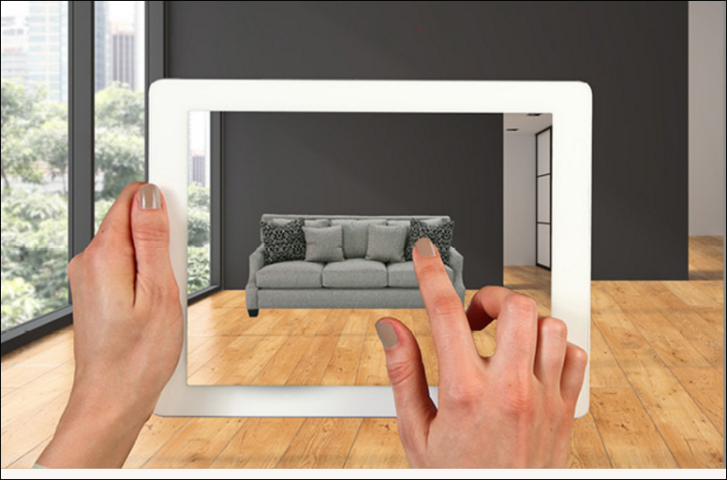

Figure 2.1

# Objective:

Furniture shopping and visualizing pieces in your home is difficult, which is why we saw the need to create a way for our customers to envision a piece in their home with their existing flooring, wall colors and decor, make it their own, and trust in their investment.

We created an AR catalog app to help customers visualize how certain pieces of furniture would fit and look in their very own homes. Customers simply launch the app on their smartphone or tablet, and use the camera function to capture an image of a room in their home. The customer can then select different items from the catalog to see how the finished, assembled piece of furniture will look in their home before they purchase.

Simply place the Target in the spot where you're considering adding a new piece of furniture, scan the Target with the augmented reality app on your mobile device and select the desired item.

The augmented reality feature then projects the item into your home by layering it over a real-time view of your room captured through your device's camera. The app also lets you experience the scale of the objects in relation to your living space.

# 4. Related Work:

Augmented reality (AR) technology makes it possible for the digital realm and the real world to combine in a seamless environment. With AR, digital components and overlays work to enhance and elevate real life scenarios in countless ways. Not only is augmented reality consumed by only tech corporations and gaming communities, but it is also becoming a more mainstream technology embraced by large retailers and customers alike. Many major consumer-driven companies are now successfully using augmented reality technology and AR apps to enrich their customers’ experiences and interactions with their brand, to ultimately boost sales.

Lego and Converse have all been active in using AR to boost their retail presence and sales through enriching their customer interaction and buying experience. Here’s how:

## 4.1 Lego

Lego is in the process of implementing AR-powered kiosks and product boxes into retail locations of theirs around the world. Customers can use the kiosk to scan the box of the Lego kit they are considering purchasing, and show their children exactly what the finished product will look like, in 3D. The assembled image appears on a screen on the kiosk, and shows a real-life view of the very Lego set they are thinking about buying. This impressive technology helps customers make their purchasing decision with more confidence, and adds an intriguing shopping experience for both children and their parents. Example shown in figure 4.1

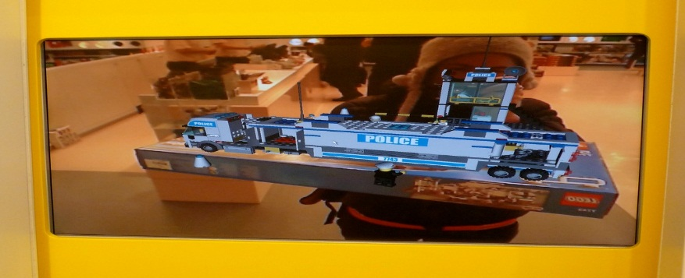

**Figure 4.1**

## 4.2 Converse

Converse uses innovative technology to show how shoes will be tried on in the near future. With their AR-fueled Converse Sampler app, the customer can select any shoe from the Converse catalog and simply point the phone towards your foot to see how the (virtual) shoe will look wearing it. This particular app even supports purchases, so the customer can have the full retail experience of shopping, trying on shoes, and making a purchase all through the power of AR. Example shown in Figure 4.2

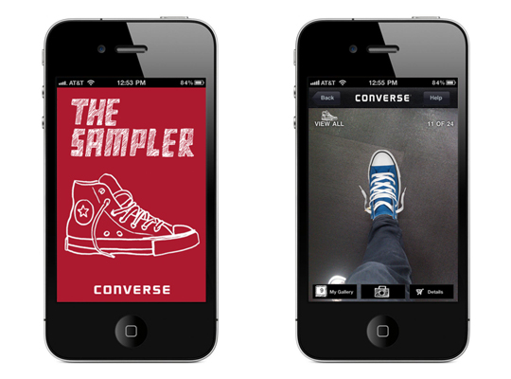

**Figure 4.2**

# 5. Initial Architecture and Design:

## 5.1 Unity



Unity is the ultimate game development platform. Use Unity to build high-quality 3D and 2D games, deploy them across mobile, desktop, VR/AR, consoles or the Web, and connect with loyal and enthusiastic players and customers.

You can create any 2D or 3D game with Unity. You can make it with ease, you can make it highly-optimized and beautiful, and you can deploy it with a click to more platforms than you have fingers and toes. What’s more, you can use Unity’s integrated services to speed up your development process, optimize your game, connect with an audience, and achieve success.

Five major versions of Unity have been released. At the 2006 WWDC show, Apple named Unity as the runner up for its Best Use of Mac OS X Graphics category (we use the fifth edition).

**Why we use it in our project?**

Flexible, fast and high-end. Unity is a ready-made solution that’s also intuitive to use and deeply customizable. With workflows that just make sense, rendering power, and highly optimized physically-based shading, you can make beautiful games fast.

Unity provides you a suite of integrated services for creating games, increasing productivity, and managing your audience.

## 5.2 Vuforia:



Is an Augmented Reality Software Development Kit (SDK) for mobile devices that enables the creation of Augmented Reality applications? It uses Computer Vision technology to recognize and track planar images (Image Targets) and simple 3D objects, such as boxes, in real-time. This image registration capability enables developers to position and orient virtual objects, such as 3D models and other media, in relation to real world images when these are viewed through the camera of a mobile device. The virtual object then tracks the position and orientation of the image in real-time so that the viewer’s perspective on the object corresponds with their perspective on the Image Target, so that it appears that the virtual object is a part of the real world scene.

The Vuforia SDK supports a variety of 2D and 3D target types including ‘marker-less’ Image Targets, 3D Multi-Target configurations, and a form of addressable Fiduciary Marker known as a Frame Marker. Additional features of the SDK include localized Occlusion Detection using ‘Virtual Buttons’, runtime image target selection, and the ability to create and reconfigure target sets programmatically at runtime.

Vuforia provides Application Programming Interfaces (API) in C++, Java, Objective-C++ (a language utilizing a combination of C++ and Objective-C syntax), and the .Net languages through an extension to the Unity game engine. In this way, the SDK supports both native development for iOS and Android while also enabling the development of AR applications in Unity that are easily portable to both platforms. AR applications developed using Vuforia are therefore compatible with a broad range of mobile devices including the iPhone, iPad, and Android phones and tablets running Android OS version 2.2 or greater and an ARMv6 or 7 processor with FPU (Floating Point Unit) processing capabilities.

Vuforia has been acquired by PTC Inc. in November 2015.

## 5.3 Firebase:



Well if you had asked that question not too long ago, the answer would have been simply, a cloud database for mobile apps.

Today, however, Firebase encompasses more than a dozen distinct developer products that provide a platform for developing, marketing, and monetizing mobile applications that are both native and web-based.

The cloud database is still there and better than ever but now Firebase is a comprehensive solution for just about everything a mobile developer needs to be successful. The Firebase products are organized into three separate categories: Develop Grow and Earn. There's also a core feature called Firebase Analytics that spans across all of these categories and tightly integrates with most of the other APIs.

The Firebase feature set provides support for many of the common tasks that face mobile developers today.

With Firebase you can measure important app usage information such as where, when, and how your app is being used, and by whom.

Users can sign up for your app and login to your app using several different identity providers such as Google, Facebook, or just plain email and password. You can detect app stability issues in the field and diagnose common causes of crashes.

Your app can provide customized experiences for different sets of users based on what OS they are using, what kind of device they have, where they're located and much more.

You can setup notification campaigns to communicate with your users and help keep them engaged.

Your app can make it easy for your users to share content with other people, even people who don't already have your app installed.

Firebase can even help you earn more money with in-app advertising.

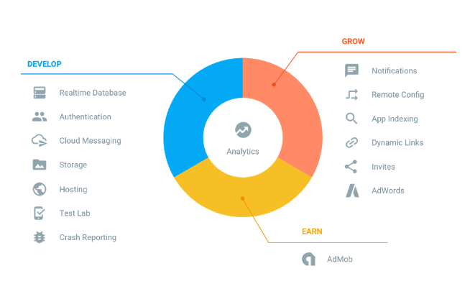

**5.3.1 Firebase analytics “develop”**

Firebase's Develop category contains APIs and features that help you build your application. In many cases, these are features that you would have to build yourself anyway, but Firebase saves you the time and trouble of having to do so.

* + - 1. **Firebase Cloud Messaging:**

Provides a way to deliver notifications, and send and receive messages to and from your users. And it works across platforms, Android, iOS, and even the web. Best of all, it's free.

* + - 1. **Firebase Authentications:**

Gives you an easy way to let users sign up for and then log in to your app. Of course, it supports Google Sign-In, but it also supports other providers, like Facebook and Twitter. You can even provide email and password authentication, which is handled entirely by the Firebase backend.

* + - 1. **The Real-time Database:**

Stores your app's data in the Cloud, and seamlessly synchronizes it with your client applications and works even when your app doesn't have network connectivity. Data is stored as JSON, which means you don't have to learn all about SQL statements.

* + - 1. **Firebase Storage:**

If your application lets users generate content, you're going to need a place to store all that content. Now, I'm talking about content that's different than what you would store in the Real-time Database, such as images, videos, or documents. For this kind of content, you want certain features, like the ability to retry uploads or downloads that get interrupted, or the ability to set security levels so that some content is public, and other content is private.

* + - 1. **Firebase Hosting:**

Firebase also provides a hosting solution in the form of a Content Delivery Network (CDN). This ensures that your content is available worldwide as fast as possible.

* + - 1. **Remote Config:**

Enables you to deliver custom experiences to users, without requiring them to download and install an update.

* + - 1. **Firebase Test Lab:**

Is how you find problems before they make it out to your users? You can run scripted tests against hundreds of devices configurations to expose bugs before they make you and your app look bad.

* + - 1. **Crash Reporting:**

Helps you understand and measure the stability of your app. You can even track the steps leading up to a crash to better understand what's causing issues for your users out in the real world.

**5.3.2 Firebase analytics “Grow”**

Firebase isn't just about helping you build your app, it also provides a set of features that are focused on acquiring and engaging with your users.

**5.3.2.1 Firebase Notifications:**

You can schedule and send messages to the right users when they are most likely to engage with your app, and you can do it across platforms for free. You can send messages to specific groups of users, by targeting specific audiences that you've created with Firebase analytics.

* + - 1. **App Indexing:**

Getting your content discovered when the user decides to search for something is another great way to engage with users, and App Indexing makes this possible. You can surface your app's content right when the user is most ready to need it, when they're searching for it.

* + - 1. **Dynamic Links:**

Your users can share content with other people, and they can participate in your app even if they don't already have it installed. Even after they go through the install process, they are taken right back to where they should be in order to continue engaging with your application and its content.

* + - 1. **Firebase App Invite:**

One of the best ways to get new users is via word of mouth from your existing users. With Firebase app Invites, your users become your biggest advocates. They can invite other people to start using your app by sharing content, thus growing your user base.

* + - 1. **Firebase AdWords:**

If part of your user acquisition strategy involves advertising, you're going to want to know how effective your campaigns are. With Firebase AdWords, combined with analytics, you can get insight into how your advertising investments are driving installations and in-app actions.

**5.3.3 Firebase analytics “Earn”**

At some point, you might want to get paid for all the hard work you've put into your app. There are multiple ways to do this in the world of mobile app development, and one of the more common ways is through advertising.

* + - 1. **Firebase AdMob:**

Provides a set of features that make it simple to integrate advertising into your app. There are different ad formats that you can choose from depending on which form factor best fits your app. And you can customize your ads for maximum effectiveness.

## Android (operating system):

Android (stylized as android) is a mobile operating system developed by Google, based on the Linux kernel and designed primarily for touchscreen mobile devices such as smartphones and tablets. Android's user interface is mainly based on direct manipulation, using touch gestures that loosely correspond to real-world actions, such as swiping, tapping and pinching, to manipulate on-screen objects, along with a virtual keyboard for text input. In addition to touchscreen devices, Google has further developed Android TV for televisions, Android Auto for cars, and Android Wear for wrist watches, each with a specialized user interface. Variants of Android are also used on notebooks, game consoles, digital cameras, and other electronics.

Android has the largest installed base of all operating systems (OS) of any kind. Android has been the best-selling OS on tablets since 2013, and on smartphones it is dominant by any metric.

Initially developed by Android, Inc., which Google bought in 2005,Android was unveiled in 2007 along with the founding of the Open Handset Alliance a consortium of hardware, software, and telecommunication companies devoted to advancing open standards for mobile devices. As of July 2013, the Google Play store has had over one million Android applications ("apps") published – including many "business-class apps" that rival competing mobile platforms– and as of May 2016 over 65 billion applications downloaded. An April–May 2013 survey of mobile application developers found that 71% of developers create applications for Android, and a 2015 survey found that 40% of full-time professional developers see Android as their priority target platform, which is comparable to Apple's iOS on 37% with both platforms far above others. In September 2015, Android had 1.4 billion monthly active devices.

* + 1. **Features Of Android OS**
       1. **Interface**

Android's default user interface is mainly based on direct manipulation, using touch inputs that loosely correspond to real-world actions, like swiping, tapping, pinching, and reverse pinching to manipulate on-screen objects, along with a virtual keyboard. Game controllers and full-size physical keyboards are supported via Bluetooth or USB. The response to user input is designed to be immediate and provides a fluid touch interface, often using the vibration capabilities of the device to provide haptic feedback to the user. Internal hardware, such as accelerometers, gyroscopes and proximity sensors are used by some applications to respond to additional user actions, for example adjusting the screen from portrait to landscape depending on how the device is oriented, or allowing the user to steer a vehicle in a racing game by rotating the device, simulating control of a steering wheel.

* + - 1. **Applications**

See also: Android software development and Google Play

Applications ("apps"), which extend the functionality of devices, are written using the Android software development kit (SDK) and, often, the Java programming language that has complete access to the Android APIs. Java may be combined with C/C++, together with a choice of non-default runtimes that allow better C++ support; the Go programming language is also supported since its version 1.4, which can also be used exclusively although with a restricted set of Android APIs. The SDK includes a comprehensive set of development tools, including a debugger, software libraries, a handset emulator based on QEMU, documentation, sample code, and tutorials. Initially, Google's supported integrated development environment (IDE) was Eclipse using the Android Development Tools (ADT) plugin; in December 2014, Google released Android Studio, based on IntelliJ IDEA, as its primary IDE for Android application development. Other development tools are available, including a native development kit (NDK) for applications or extensions in C or C++, Google App Inventor, a visual environment for novice programmers, and various cross platform mobile web applications frameworks. In January 2014, Google unveiled an framework based on Apache Cordova for porting Chrome HTML 5 web applications to Android, wrapped in a native application shell.

* **Augmented reality**

At Google I/O on May 2016, Google announced Daydream, a virtual reality platform that relies on a smartphone and provides VR capabilities through a virtual reality headset and controller designed by Google itself. The platform is built into Android starting with Android Nougat, differentiating from standalone support for VR capabilities. The software is available for developers, and was released in 2016.

# 6. Plan:

* We have accomplished many objectives of our plan such as:
* Develop android application with simple user interface
* Visualize 3D object using specific target
* Control movement ,size , rotation of 3D object
* Real authentication for the customer
* Complete Firebase Authentication
* Firebase integration with android application
* Save & retrieve furniture data from real-time database merge the unity app with android app
* Design 3D objects instead of using 3D objects of unity Assets

# 7. Current State:

Up till now, we reached to develop the desired objective according to time plan that have many features:

* **Simplicity for the user**

Convenient user interface. Keep in mind this main feature of a mobile application. It may be hard to reach, but the result is worth it - users will have no reason to switch to another app. whatever the functionality is - the simpler it's delivered, the better for you. All the content should be accessed in the simplest way possible. Let clients perform every action with ease, and you will not lose them. That is the thing that keeps mobile apps going and makes them popular.

* **Good performance**

Speed of loading mustn't keep users waiting. However, issues such as this, are usually checked by quality assurance, which is a part of software development.

* **Security**

His issue is vital to many apps. It is one of the first topics of discussion between you and software developers. No leaks of the users' private information are allowed.

* **Personalization options**

In case it's possible. Personalization is undeniably loved by everyone. Flexible settings, fonts, colors and sizes are a winner, when it comes to choosing an app among similar ones. Let them make the app look the way they want to.

* **Design both the app front end and the backend server logic at once**

Your app is more than just a beautiful UI. It’s the brains of the system – the data processing and delivery – that’re going to get you the five star rating. A complete mobile app framework includes not only the front end but powerful back end server software for comprehensive workflow execution, data integration, server-powered data calculation, and so on. Whether it lives in your network or in the cloud, you want the backend processing server for your app to be lightning fast and powerful to deliver the best user experience.

* **Targeted**

Knowing your target audience is very important in every field of business. It is a vital step in the building and marketing of a successful mobile application. For mobile application developers, the correct identification of a target audience is of utmost importance due to the lack of face-to-face sales opportunities. Identifying your mobile application's target market involves conducting research before, during, and after the actual development process.

* **The Bottom Line**

People like to use mobile apps that are easy to use and fulfill their needs. This is what you ought to keep in mind while building and designing your app. A good app will be user-friendly, simple, innovative, and solve problems. It is about encouraging users to use your app. A great app is the one that satisfies the end user.

* **Responsive Design**

Great apps have a responsive design. Responsive apps adjust their layout dynamically according to the screen dimensions of the device they're running on. While you can achieve responsiveness by having the app detect the screen dimensions and load a different layout for every brand of smartphone and pad computer, this tactic will make your app huge, unwieldy, and very hard to maintain. The smart way to build responsive apps requires a development platform that provides an automatically responsive user interface model and generates an optimized experience on every device from a single code base so that you don't have to worry about the details.

* + We have accomplished many objectives of our plan such as:
  + Develop android application with simple user interface
  + Visualize 3D object using specific target
  + Control movement ,size , rotation of 3D object
  + Real authentication for the customer

# 8. Future work:

* Complete Firebase Authentication
* Firebase integration with android application
* Save & retrieve furniture data from real-time database merge the unity app with android app
* Design 3D objects instead of using 3D objects of unity Assets

# 9. Conclusion:

Augmented reality technology is becoming much more of mainstream among retail businesses. Consumers are increasingly tech savvy who tend to make their purchasing decision from home or on a mobile device. Augmented reality is the Segway for retailers to create more meaningful, memorable shopping experiences for customers while leveraging your digital audience in the process.

Augmented reality technology and AR apps have limitless marketing potential for retailers. In order to stay competitive and relevant in your industry, consider embracing and integrating AR into your business.

In the end, every business will eventually need to develop a mobile app to allow customers to reach them from wherever they are. It’s surprising how tapping into some of your phone’s lesser known features can facilitate an engaging connection with your customers.

# 10. References

https://www.vuforia.com/Features

https://firebase.google.com/features

https://en.wikipedia.org/wiki/Android_(operating_system)

https://en.wikipedia.org/wiki/Augmented_reality

https://developer.android.com/index.html

http://www.digitaltrends.com/mobile/best-augmented-reality-apps/

http://mashable.com/category/augmented-reality/

http://computer.howstuffworks.com/augmented-reality.htm

https://www.theguardian.com/technology/augmented-reality

https://www.youtube.com/watch?v=09vxKN1zLNI

https://appreal-vr.com/blog/markerless-vs-marker-based-augmented-reality/